TECH HACK 2021 (IoT)

**TEAM** **MEMBERS**

**MEGHANA (19H61A12D6)**

**AISHWARYA (19H61A12G2)**

**SOWMYA (19H61A12H1)**

**ASHRITHA (19H61A12D9)**

**PROJECT** **NAME**

**SMART** **PARKING** **SYSTEM**

**TEAM** **NAME**

**ENRON**

***INTRODUCTION:***

Currently, most of the existing car parks do not have a systematic system. The problem that always occurs at the car park is time being wasted in searching for the available parking spaces. Users will keep on circling the parking area until they found a vacant parking slot.

This problem usually occurs in urban areas, where number of vehicles is higher as compared to the availability of parking spaces. These ineffective conditions happened because of the lack of implementation in technologies which are available in the market today.

Nowadays many local car parks are built inside shopping mall or multipurpose building to provide parking lot to car driver.

Smart parking is a parking solution that can include in-ground smart parking sensors, cameras or counting sensors. These devices are usually embedded into parking spots or positioned next to them to detect whether the parking bays are free or occupied. This happens through real-time data collection. The data transmitted to a is smart then parking mobile application or website, which communicates the availability to its users. Some companies also offer other in-app information, such as parking prices and locations. This gives you the possibility to explore every parking option available to you.

As a result of using Smart Parking, people who are looking to find a parking spot find it in the most efficient way possible and companies or municipalities can optimize their parking territories. It also makes cities more livable, safer and less congested.

***PROJECT*** ***DETAILS****:*

Our main moto of this project is to organize vehicles in any parking lot.

* Every parking space is assigned with an ID.
* Every parking space is connected with one major device which stores the overall data of all parking spaces with unique ID and prompts the vehicle while entering the parking lot.
* That device will give the information such as- which parking space is empty and guides the vehicle to the nearby empty parking space.
* While parking the vehicle in a parking space, the driver enters the information such as-- how long he/she is going to park the vehicle.
* If there is no empty space the device will automatically gathers all the information and guides the vehicle to nearby parking space which has least waiting time.

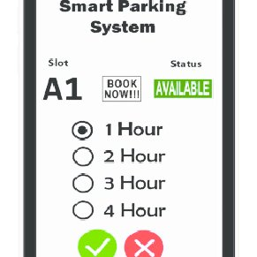

* Depending on the waiting time the driver will pay the respective charges and departs his vehicle from the parking space.
* If he/she takes additional time to collect the vehicle, the device will show how much fine he/she has to pay.
* Only after the successful payment of all charges the vehicle is allowed to go out of the parking lot.

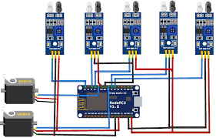

***BLOCK DIAGRAM:***

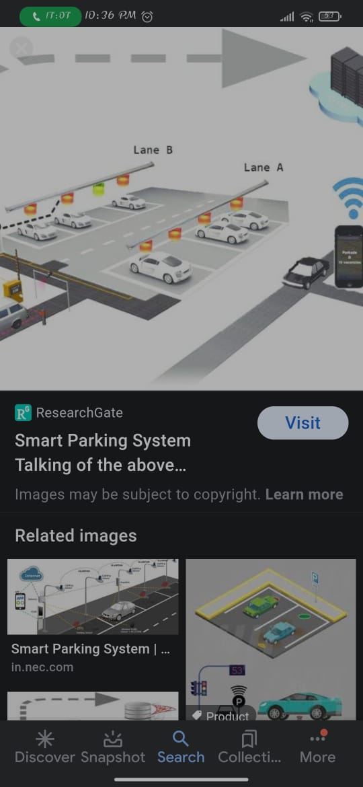

***BENEFITS****:*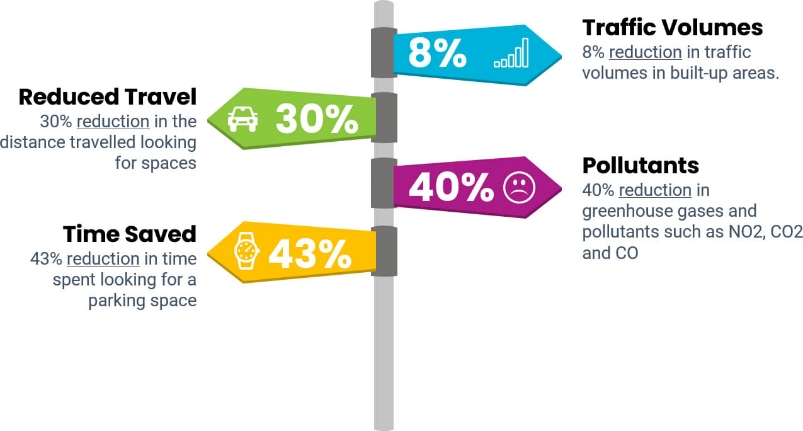

* *Environment:*

Smart Parking can be combined with [Smart Environment](https://www.manxtechgroup.com/iot-test-vehicles-on-manx-roads/), measuring air quality and parking space availability.

* ***Convenience:***

The convenience factor is of particular importance for spaces reserved for disabled drivers, public service or emergency vehicles.

* ***Reduced Traffic:***

optimises traffic flows in built-up areas.

* ***Safety:***

Decreased searching for spaces can reduce accidents by ensuring drivers maintain their attention rather than browsing for spaces or making rash manoeuvres.

* ***Smart City*:**

Smart Parking will soon become a necessity for any city or town wishing to embrace Smart City technologies.

* ***Integrated Payments:***

Smart Parking systems can include real-time and electronic payment methods via an app or a browser.

*Python Code:*

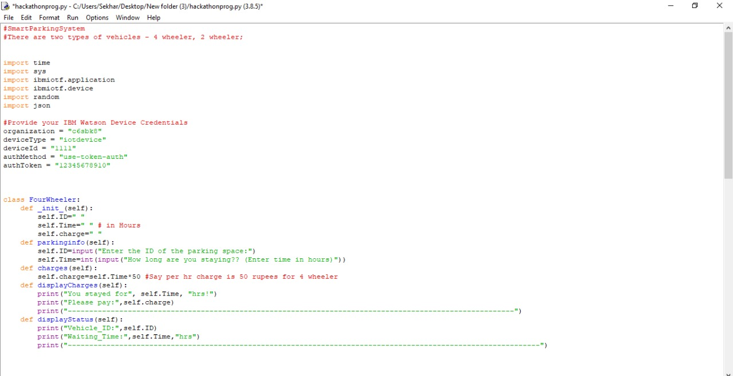

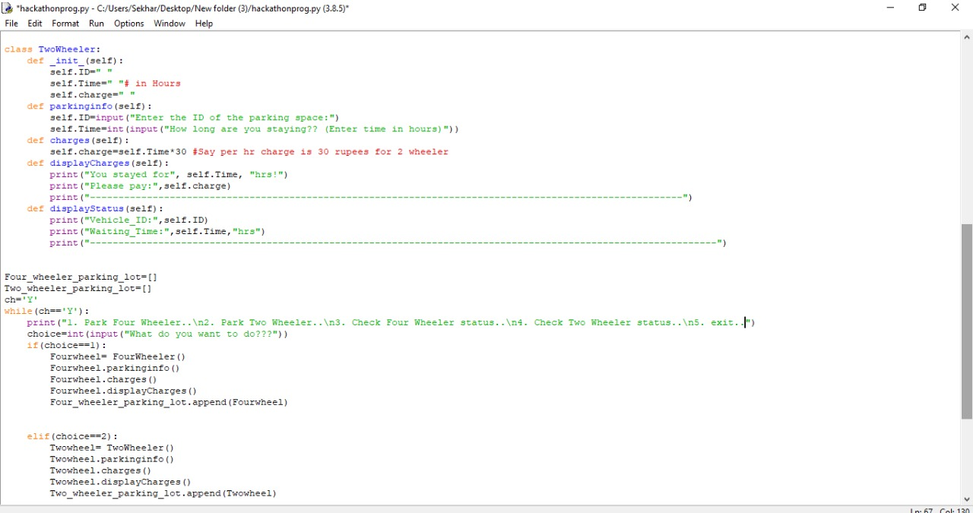

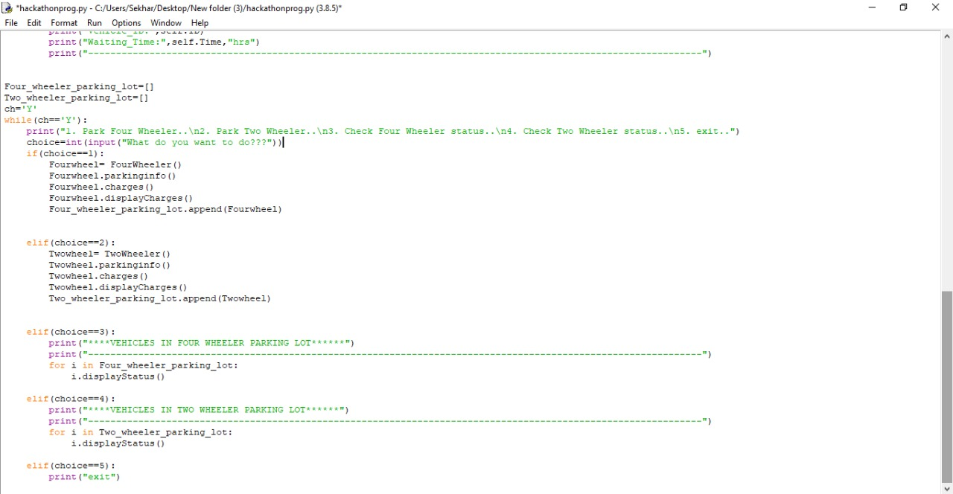

*Code Output:*

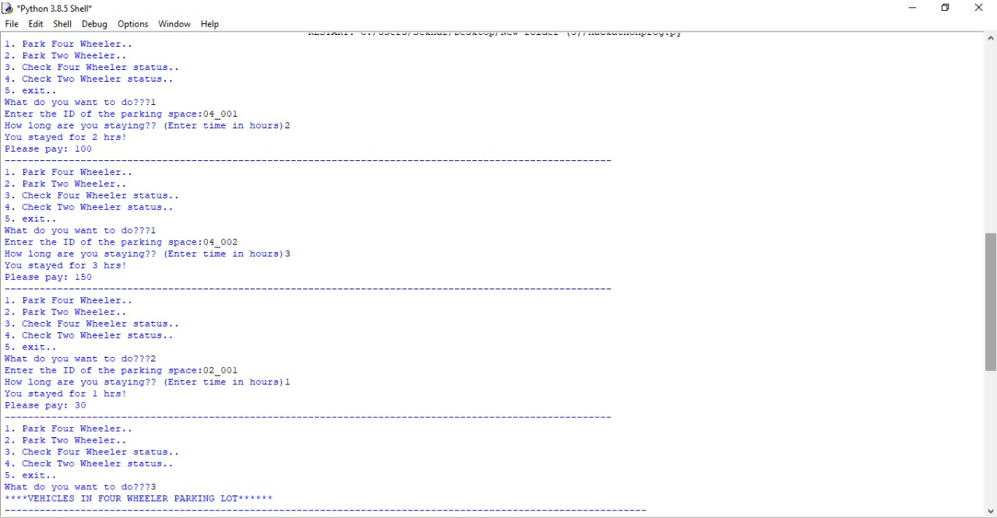

**

*Node-red Flow:*

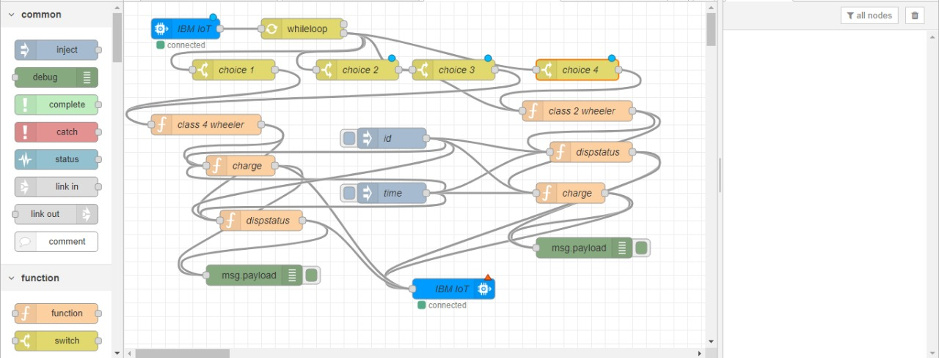

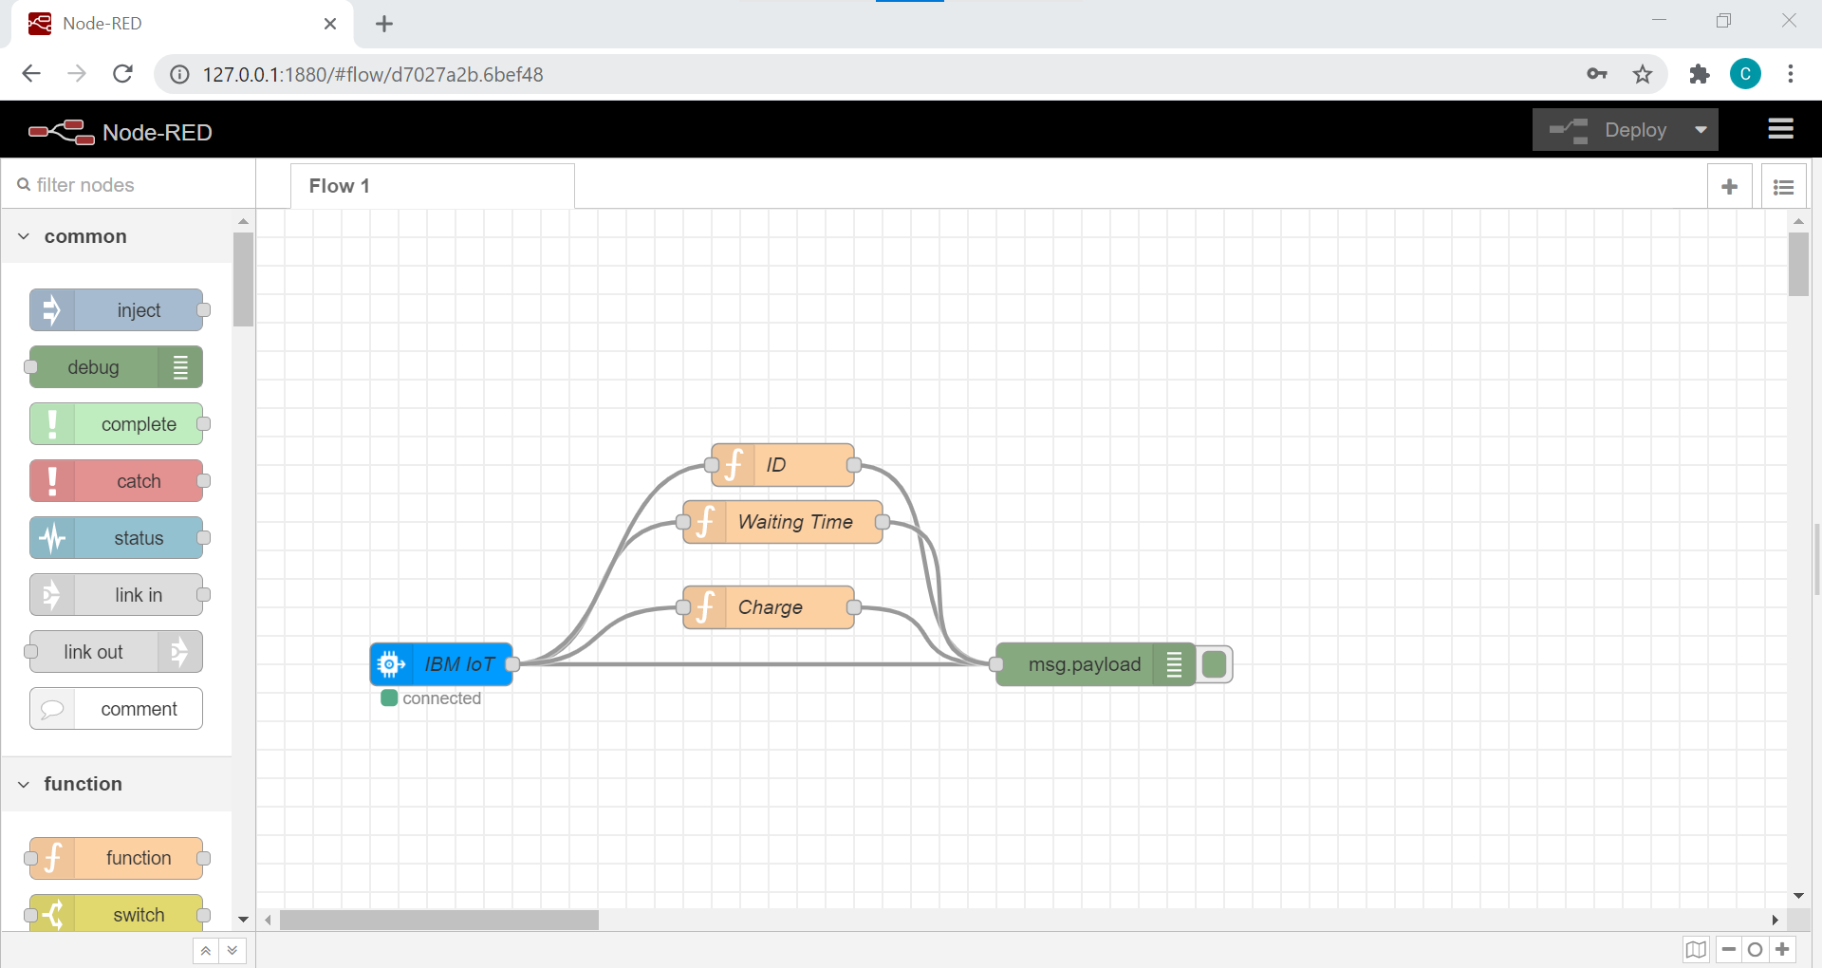

T

H

A

N

K

Y

O

U

*HAVE ANY QUERIES?*

*Please do contact us:*

*7995267708,*

*8897102868.*